1. **ReactJS-HOL**

**App.js:**

function App() {

  return (

    <div>

      <h1>Welcome to the first session of React</h1>

    </div>

  );

}

export default App;

**OUTPUT :**

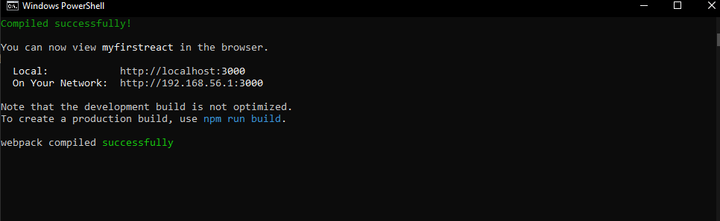

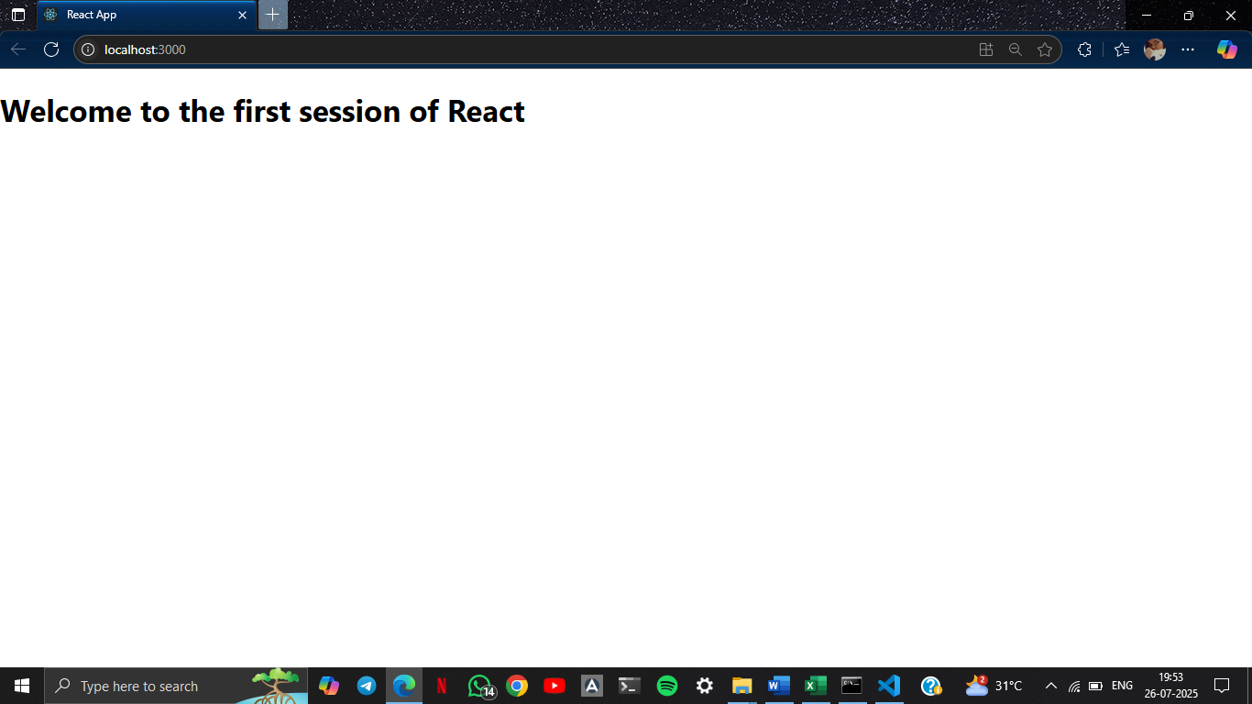

1. **ReactJS-HOL**

**Home.js :**

import React, { Component } from 'react';

class Home extends Component {

  render() {

    return <h2>Welcome to the Home page of Student Management Portal</h2>;

  }

}

export default Home;

**About.js :**

import React from 'react';

function About() {

  return <h2>Welcome to the About page of the Student Management Portal</h2>;

}

export default About;

**Contact.js :**

import React from 'react';

function Contact() {

  return <h2>Welcome to the Contact page of the Student Management Portal</h2>;

}

export default Contact;

**OUTPUT :**

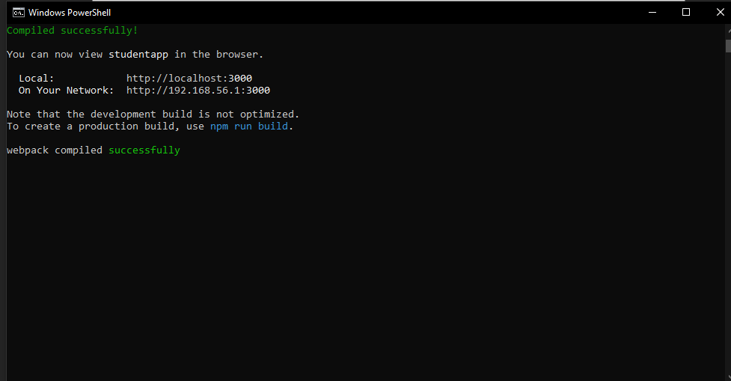

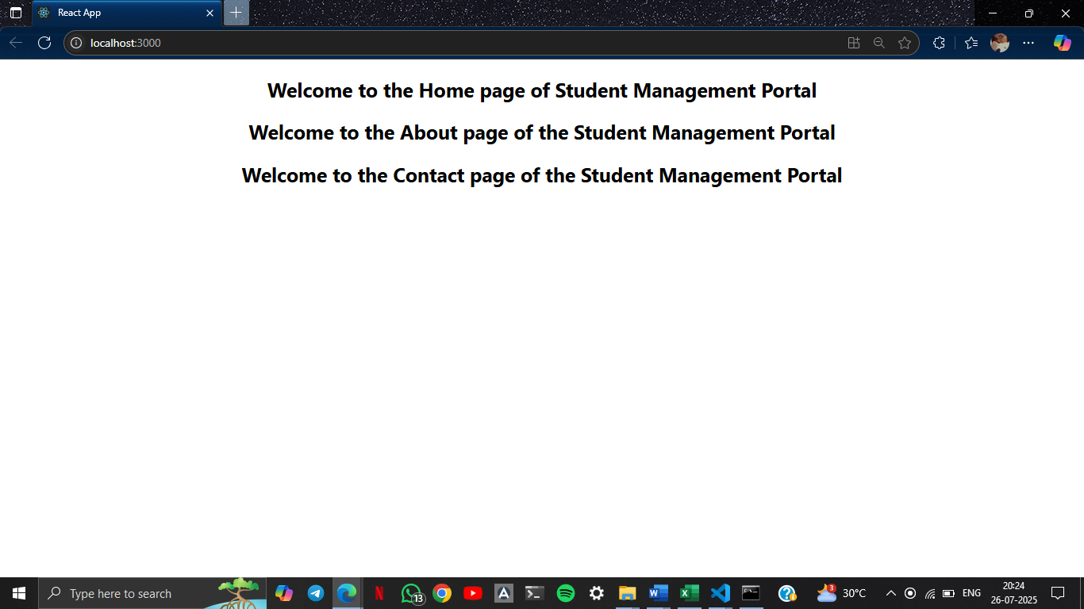

1. **ReactJS-HOL**

**CalculateScore.js :**

import React from 'react';

import '../Stylesheets/mystyle.css';

function CalculateScore() {

  const name = "Shriya Surendran C H";

  const school = "Excel Public School";

  const totalMarks = 1166;

  const goalMarks = 1200;

  const average = (totalMarks / goalMarks) * 100;

  return (

    <div className="score-container">

      <h2>Student Score Calculator</h2>

      <p><strong>Name:</strong> {name}</p>

      <p><strong>School:</strong> {school}</p>

      <p><strong>Total Marks:</strong> {totalMarks}</p>

      <p><strong>Goal Marks:</strong> {goalMarks}</p>

      <p><strong>Average Score:</strong> {average.toFixed(2)}%</p>

    </div>

  );

}

export default CalculateScore;

**mystyle.css :**

.score-container {

  background-color: #b7e7ee;

  padding: 20px;

  border: 2px solid #ccc;

  border-radius: 10px;

  width: 400px;

  margin: 40px auto;

  text-align: left;

  font-family: Arial, sans-serif;

}

.score-container h2 {

  color: #1d3c4b;

  text-align: center;

}

**OUTPUT :**

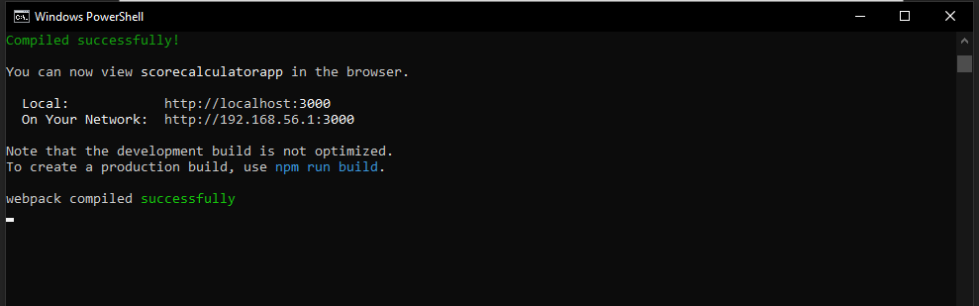

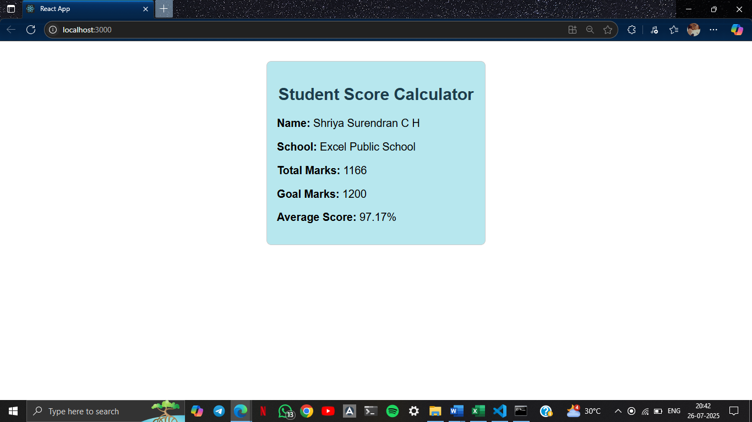

1. **ReactJS-HOL**

**Post.js :**

import React from 'react';

class Post extends React.Component {

  render() {

    const { title, body } = this.props;

    return (

      <div style={{ marginBottom: '20px', borderBottom: '1px solid #ccc' }}>

        <h3>{title}</h3>

        <p>{body}</p>

      </div>

    );

  }

}

export default Post;

**posts.js :**

import React, { Component } from 'react';

import Post from './post';

class Posts extends Component {

  constructor(props) {

    super(props);

    this.state = {

      posts: [],

      hasError: false,

    };

  }

  loadPosts = () => {

    fetch('https://jsonplaceholder.typicode.com/posts')

      .then((response) => response.json())

      .then((data) => this.setState({ posts: data.slice(0, 5) }))

      .catch((error) => {

        console.error("Fetch error:", error);

        this.setState({ hasError: true });

      });

  };

  componentDidMount() {

    this.loadPosts();

  }

  componentDidCatch(error, info) {

    alert("An error occurred while rendering Posts.");

    console.error("Error:", error, "\nInfo:", info);

    this.setState({ hasError: true });

  }

  render() {

    const { posts, hasError } = this.state;

    if (hasError) {

      return <h2>Something went wrong.</h2>;

    }

    return (

      <div>

        <h2>Blog Posts</h2>

        {posts.map((post) => (

          <Post key={post.id} title={post.title} body={post.body} />

        ))}

      </div>

    );

  }

}

export default Posts;

**OUTPUT :**

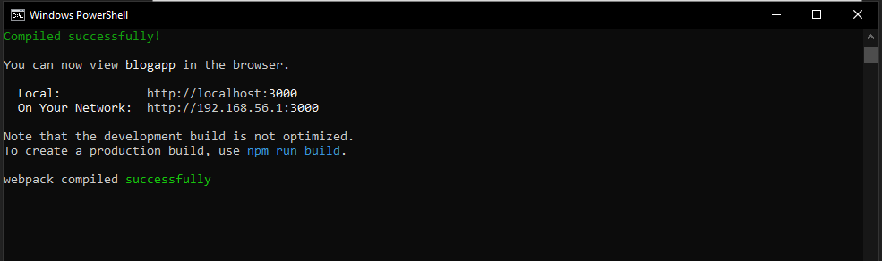

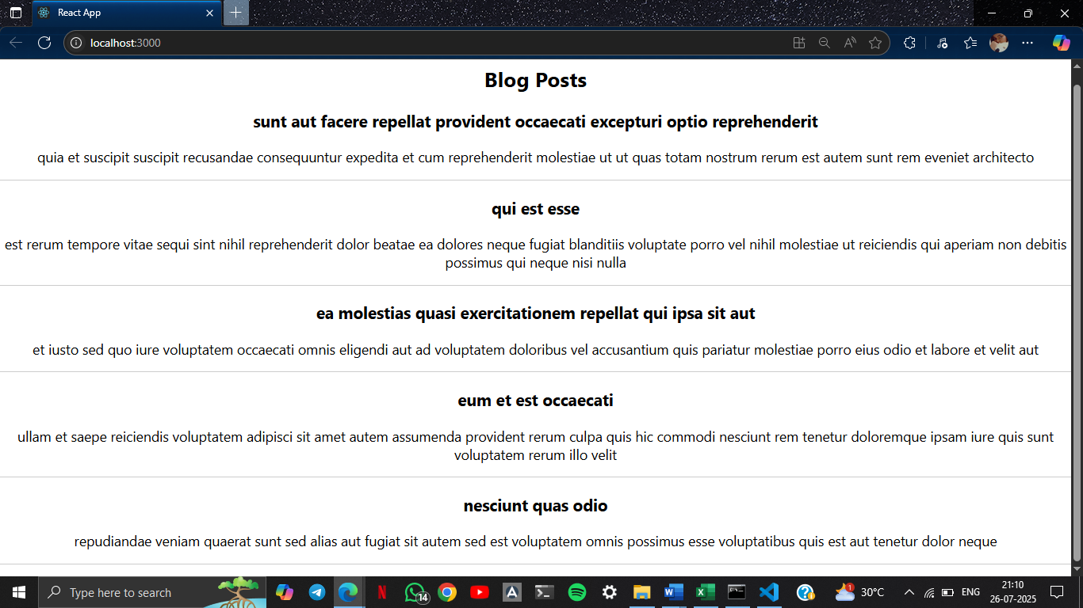

1. **ReactJS-HOL**

**CohortDetails.js :**

import styles from './CohortDetails.module.css';

function CohortDetails(props) {

    return (

        <div className={styles.box}>

            <h3 style={{ color: props.cohort.currentStatus === 'ongoing' ? 'green' : 'blue' }}>

                {props.cohort.cohortCode} - <span>{props.cohort.technology}</span>

            </h3>

            <dl>

                <dt>Started On</dt>

                <dd>{props.cohort.startDate}</dd>

                <dt>Current Status</dt>

                <dd>{props.cohort.currentStatus}</dd>

                <dt>Coach</dt>

                <dd>{props.cohort.coachName}</dd>

                <dt>Trainer</dt>

                <dd>{props.cohort.trainerName}</dd>

            </dl>

        </div>

    );

}

export default CohortDetails;

**CohortDetails.module.css :**

.box {

  width: 300px;

  display: inline-block;

  margin: 10px;

  padding: 10px 20px;

  border: 1px solid black;

  border-radius: 10px;

}

dt {

  font-weight: 500;

}

**OUTPUT :**

